Project Gate Page

A18 – Group 111 - Icook

**Dor Shabat – דור שבת - 316575620  
Yuval Rozner – יובל רוזנר - 207756552  
Niv Dahan – ניב דהן - 308215086  
Nitzan Ezra – ניצן עזרא - 208697334**

**Icook** is a web application that offers an interactive platform for cooking enthusiasts. It features a diverse collection of recipes, each with detailed instructions for preparation. Users can navigate through these recipes, select one, and follow a step-by-step guide to cook a variety of dishes. The application includes functionality to adjust ingredient quantities based on the desired number of servings, catering to different cooking needs. Additionally, Icook is designed to be responsive, ensuring a consistent experience across various devices. The interface incorporates a straightforward navigation system, facilitated by a dedicated navigation bar, enabling users to explore recipes and cooking guides seamlessly.

**Key Features:**

* Recipe Browsing: Users can explore a curated list of recipes on the homepage.
* Detailed Instructions: Each recipe comes with comprehensive preparation steps and ingredient lists.
* Interactive Cooking Guide: The CookWithMe feature guides users through the cooking process with a visual progress bar.
* Responsive Design: Optimized for various device sizes, providing a consistent user experience across desktops, tablets, and mobile devices.
* Accessibility: Navigation controls and UI elements are designed to be accessible and user-friendly.

**Technologies Used:**

* **React:** A JavaScript library for building user interfaces with component-based architecture.
* **Tailwind CSS:** A utility-first CSS framework for styling the application.
* **React Router:** A standard library for routing in React, allowing navigation between different components.
* **Database:** A Json file used as a database for all the recipes information.

Direct link to the website: <https://yuvalrozner.github.io/Icook>

Link to the repository: <https://github.com/YuvalRozner/Icook>

Link to MTW: <https://www.morethanwallet.com/app/689>

**Assignments**

|  |  |  |
| --- | --- | --- |
| **שם חבר צוות** | **משימות שהוקצו** | **משימות שהושלמו** |
| **דור** (מהנדס מערכת) | 1. ארכיטקטורת האתר – מעבר לreact . 2. כתיבה מחדש של חלק מהקוד ב react . 3. כתיבת תיק – user guide. | כל המשימות |
| **יובל** | 1. ארכיטקטורת האתר – מעבר לreact . 2. כתיבה מחדש של חלק מהקוד ב react . 3. כתיבת תיק programing manual . | כל המשימות |
| **ניצן** | 1. ארכיטקטורת האתר – מעבר לreact . 2. כתיבה מחדש של חלק מהקוד ב react . 3. עדכון use case | כל המשימות |
| **ניב** | 1. ארכיטקטורת האתר – מעבר לreact . 2. כתיבה מחדש של חלק מהקוד ב react . 3. עדכון דרישות | כל המשימות |

**Requirements**

|  |  |
| --- | --- |
| **FR** | |
| System shall allow users to choose a recipe from a recipes list. | |
| System shall allow users to view detailed recipes. | |
| System shall feature a "Cook with Me" interactive cooking assistant. | |
| System shall offer Manual mode. | |
| System shall offer Automatic mode. | |
| System shall provide a progress bar. | |
| System shall allow users to control the timer. | |
| System shall enable users to adjust recipe quantities. | |
| **NFR** | |
| **Requirement** | **Type** |
| The website shall be user-friendly, with intuitive navigation and a responsive design suitable for various devices (desktop, tablet, smartphone). | Usability |
| The website shall provide images for recipes, steps instructions and cooking progress. | Usability |
| The website shall load within 3 seconds on standard broadband connections, and recipe steps shall advance smoothly in "Automatic Mode" without lag. | Performance |
| The system shall support an increasing number of users and recipes without degradation in performance or usability. | Scalability |
| The website shall be available 24/7 | Availability |
| The website’s codebase shall be structured and documented to facilitate easy updates, bug fixes, and feature enhancements. | Maintainability |
| The website shall offer customization options for users, such as theme selection, layout preferences, and notification settings, to enhance the personal user experience. | Customization |
| Adjust recipe quantities will based on the number of serving the user choose. | Customization |
| Manual mode, Automatic mode, Progress bar, timer, timer controllers, recipe adjustments – will all be a part of the "Cook with Me" feature. | Structure |
| The website must maintain high-quality, engaging, and error-free content to attract and retain visitors. | Content Quality |
| The design should focus on simplicity and ease of use, avoiding unnecessary elements. | Design |

**Architecture**

**Use Case**

**Folder and Files Diagram :**

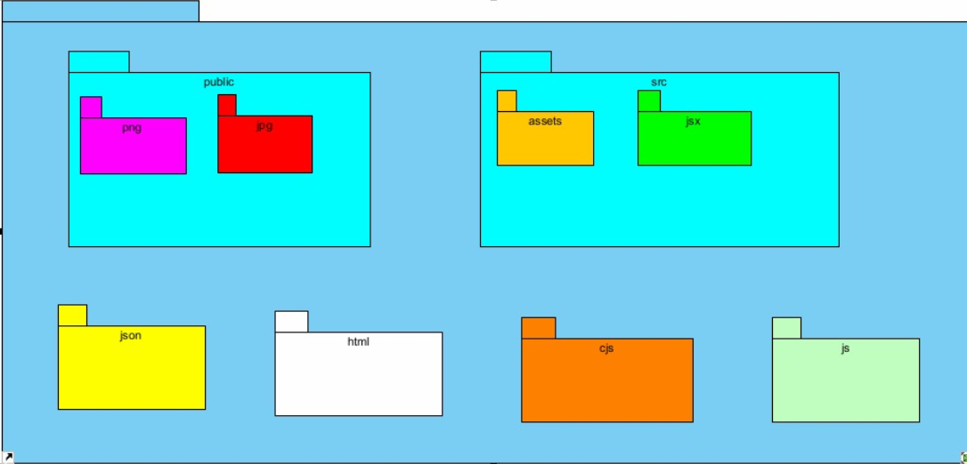

**Database Structure:**  
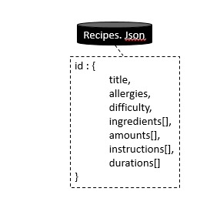

**Programmer's guide**

**in a separate file –** [**Link to file**](Programmer%20Manual.docx)

**User's Guide**

**in a separate file –** [**Link to file**](User%20Guide.docx)